5. A Local’s Guide to Fifth Avenue South and Third Street South

SEO Title
Best Dining, Shopping, and Lifestyle in Downtown Naples

Meta Description
Explore Fifth Avenue South and Third Street South, the heart of downtown Naples known for luxury shopping, fine dining, and coastal charm.

Target Keywords
Fifth Avenue South Naples, Third Street South Naples, downtown Naples lifestyle, Naples luxury shopping

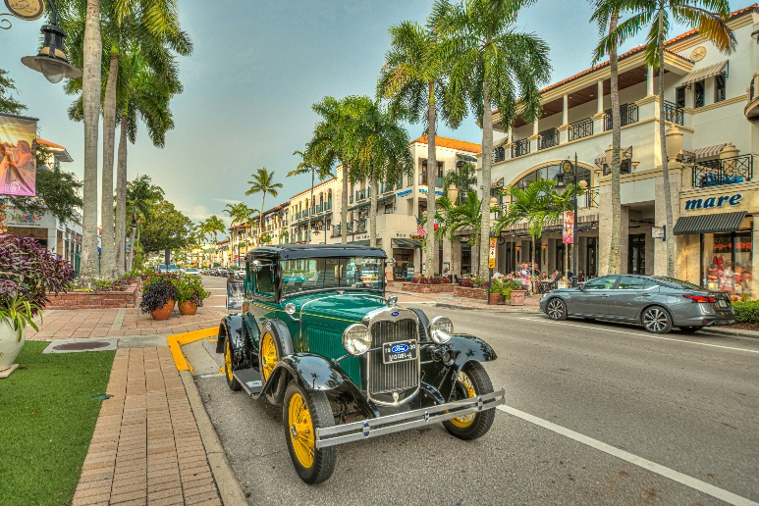

Internal Linking Opportunities
- Old Naples listings
- Downtown Naples homes page
- Naples lifestyle blog section

Suggested CTA
Want to live close to Naples’ best restaurants, shopping, and beaches? Contact Michael Giacalone at Premier Sotheby’s International Realty for private market insights and available listings. 239.431.0321

The Heartbeat of Downtown Naples
While Naples is known for its luxury homes and waterfront estates, the city’s vibrant downtown districts are equally important to the lifestyle buyers seek.
Fifth Avenue South and Third Street South serve as the social and cultural center of Naples. These walkable districts blend upscale dining, boutique shopping, art galleries, cafés, and entertainment into a uniquely charming coastal atmosphere.
Fifth Avenue South is known for its lively energy and variety of experiences. Residents and visitors can enjoy fine dining, rooftop cocktails, luxury boutiques, and seasonal events throughout the year. The avenue also hosts art shows, live performances, and community celebrations that create a welcoming atmosphere.
Third Street South offers a slightly more relaxed and historic feel. Lined with palm trees and lush landscaping, the district features elegant restaurants, outdoor cafés, local markets, and luxury shopping just steps from the beach.
For homeowners in Port Royal, Old Naples, and Aqualane Shores, access to these districts is one of the area’s greatest lifestyle advantages. Residents can spend mornings at local coffee shops, afternoons shopping or dining, and evenings enjoying live entertainment—all without leaving downtown.
The combination of coastal beauty, luxury amenities, and walkability is part of what makes Naples stand apart from many other waterfront markets.
For buyers considering a move to Naples, experiencing Fifth Avenue South and Third Street South firsthand often helps them understand why so many people fall in love with the area.

